# Caching for ICAP

## Choosing a Caching Mechanism

Three main options I found for caching on Azure:

* Azure Table Storage
* Azure Cache for Redis
* Azure CosmoDB

## Azure Table Storage

Pros:

* Fast (~50ms insert, ~50ms query)
* Data is persisted
* Scaled to 500TB
* Code is compatible with Cosmos DB should the client require that solution.

### Cons:

* Global Replication is possible, but secondary region is only read only
* Limited to 1MB per entity

## Azure Cache for Redis

### Pros:

* More features (pub/sub, content eviction)

### Cons:

* No Data Persistence unless on premium (£307 a month – cheapest premium)
* Low Cache Sizes
* More expensive than Table Storage

## Azure Cosmo DB

### Pros:

* Single Digit millisecond response time
* 99.999% availability
* Multi-master global distribution
* Code is compatible with Table Storage should the client require that solution.

Cons:

* Expensive
* Overkill for what we need

## Spike Testing

#### Azure Table Storage

Function to insert an entity (file hash, filetype, file status).

Function to retrieve an entity based on an existing hash.

23745 entities inserted over the weekend

Average times:

* Inserting Entity – 43.4ms
* Retrieving Entity based on hash – 23.7ms

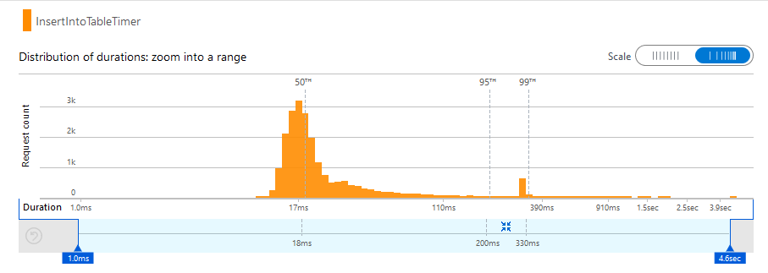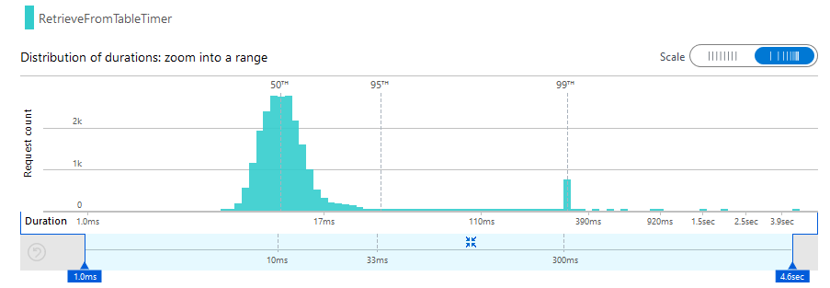

#### Azure Cache for Redis

Function to insert an entity (file hash, filetype, file status).

Function to retrieve an entity based on an existing hash.

Average Times:

* Inserting Entity – 86.5ms
* Retrieving Entity based on hash – 85.4ms

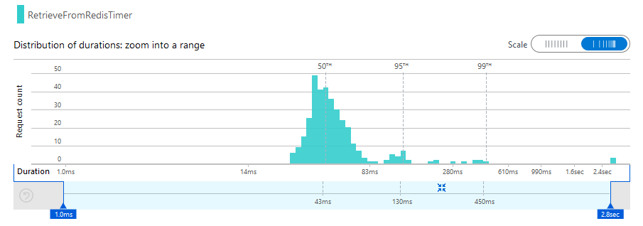

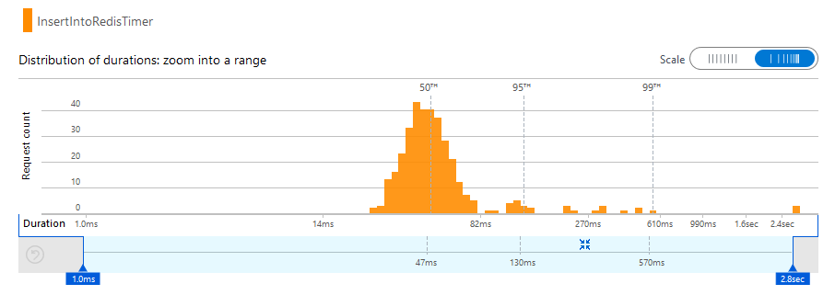

These times are based on the completion of the whole function (creating client to data storage, creating entity, performing action).

I wrapped the executing of the action in a stopwatch to isolate just those metrics. From this I found Redis retrieval and insert is quicker than Azure table storage. However it does take longer to complete the whole function due to the creation of the Redis client taking longer than the creation of the Storage Account client.

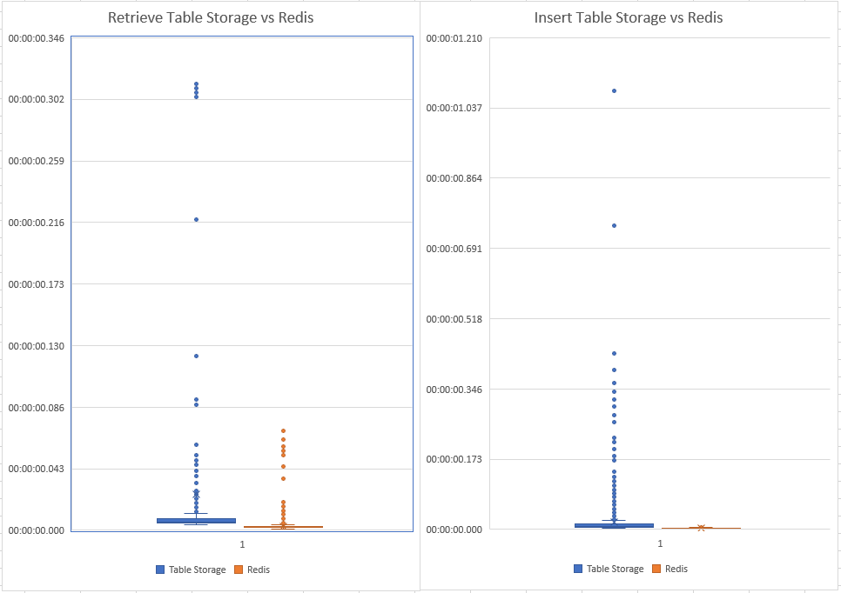

Documents recommend keeping the connection to the Redis cache open and re-using this across multiple calls, however more research would need to be done to know if this is possible.

Another consideration would be the lack of persistence on Redis outside of the premium tier. We would need to store the data externally (SQL, NoSQL) and load on a fresh instance of Redis.